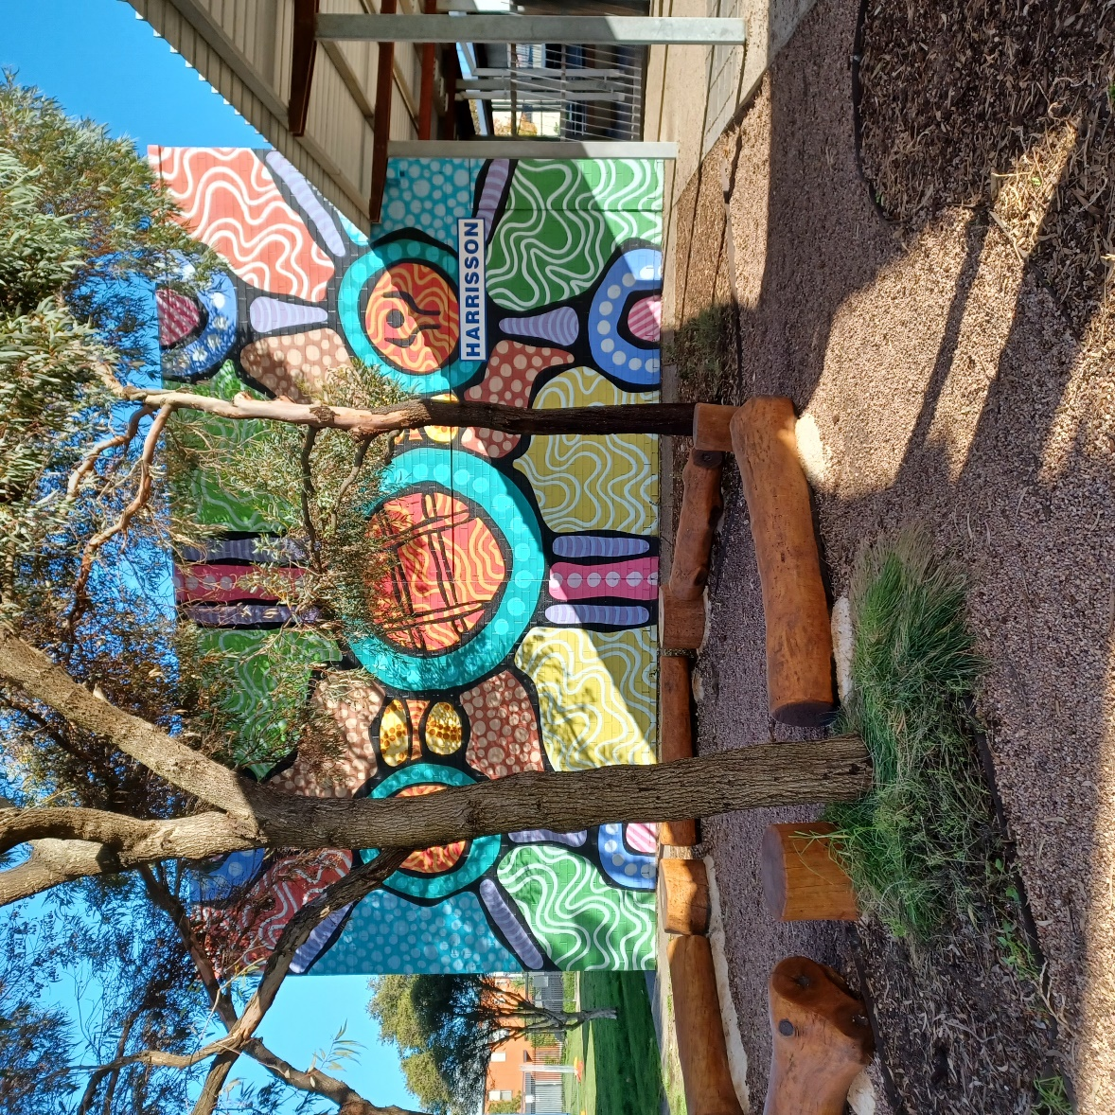

Newsletter

Term 1 Week 3

14th February 2024

|  |
| --- |
|  |
| <https://sway.cloud.microsoft/IUhsc6ZIljJ9m0kB?ref=Link> |
|  |
|  |